| Experiment No.2 |
| --- |
| Apply Tokenization on given English and Indian Language Text |
| Date of Performance: |
| Date of Submission: |

**Aim:** Apply Tokenization on given English and Indian Language Text

**Objective:** Able to perform sentence and word tokenization for the given input text for English and Indian Langauge.

**Theory:**

Tokenization is one of the first step in any NLP pipeline. Tokenization is nothing but splitting the raw text into small chunks of words or sentences, called tokens. If the text is split into words, then its called as 'Word Tokenization' and if it's split into sentences then its called as 'Sentence Tokenization'. Generally 'space' is used to perform the word tokenization and characters like 'periods, exclamation point and newline char are used for Sentence Tokenization. We have to choose the appropriate method as per the task in hand. While performing the tokenization few characters like spaces, punctuations are ignored and will not be the part of final list of tokens.

**Why Tokenization is Required?**

Every sentence gets its meaning by the words present in it. So by analyzing the words present in the text we can easily interpret the meaning of the text. Once we have a list of words we can also use statistical tools and methods to get more insights into the text. For example, we can use word count and word frequency to find out important of word in that sentence or document.

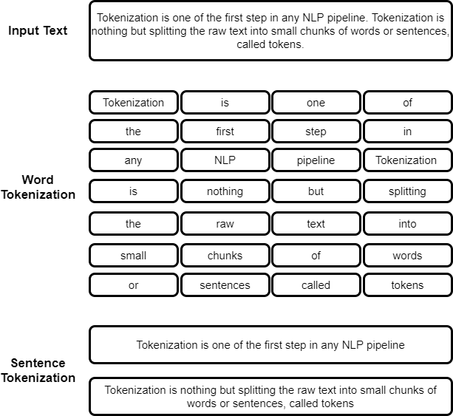

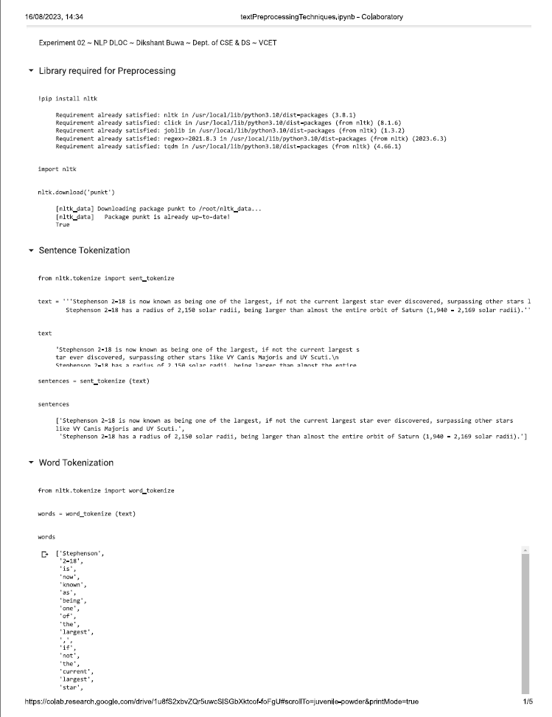

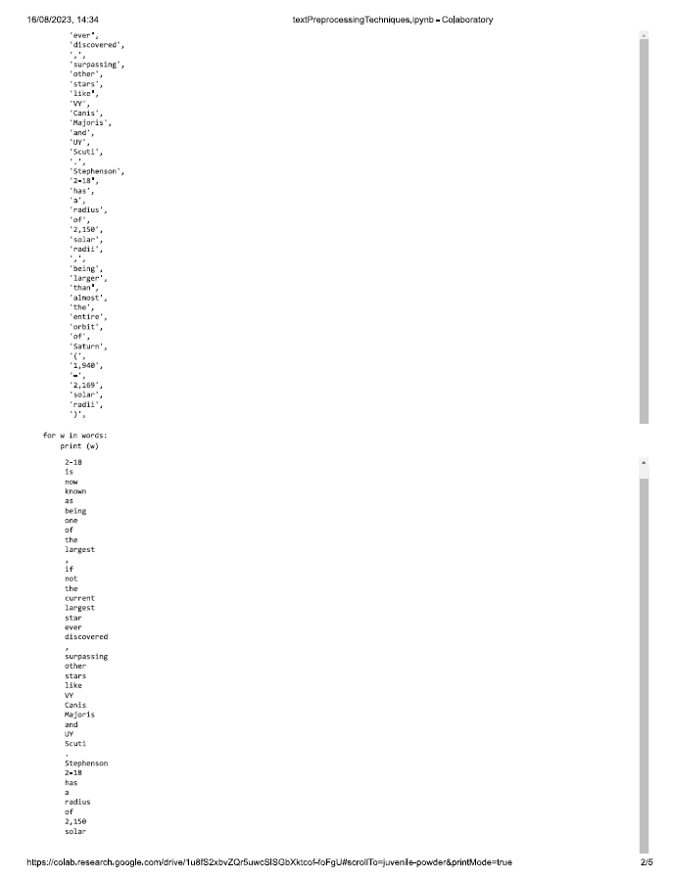

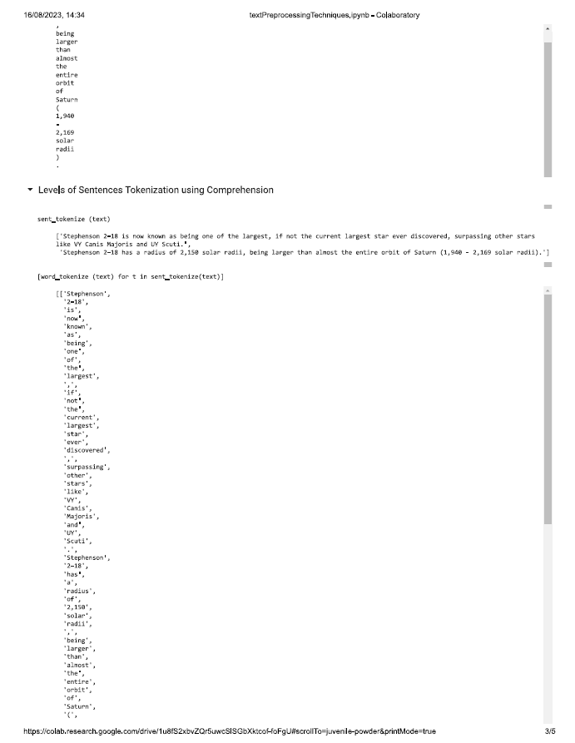

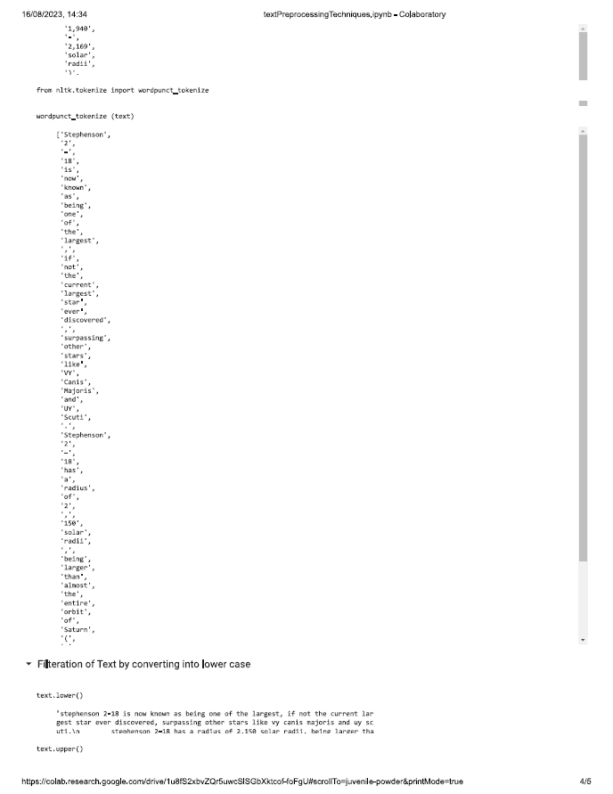

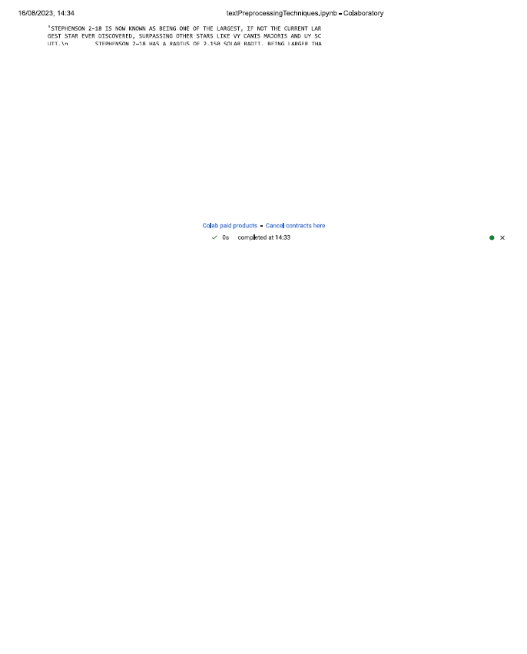

**Conclusion:**

Tools used for tokenization of Indian language input are:

1. IndicNLP Library: IndicNLP is an open-source Python library that provides tokenization tools for several Indian languages. It includes support for various scripts like Devanagari (used for Hindi, Marathi, Sanskrit, etc.), Tamil, Bengali, and more.

2. Stanford NLP: The Stanford NLP library provides support for tokenizing Indian languages, including Hindi and Telugu, using their pre-trained models.

3. Multilingual BERT Models: Multilingual BERT models, such as mBERT and IndicBERT, have been used to tokenize text in various Indian languages. These models can handle multiple languages and have shown good performance for tokenization in Indian scripts.

4. Pynini for Sanskrit: Pynini is a library for working with finite-state transducers and grammars. It has been used to create tokenization and morphological analysis tools specifically for Sanskrit, which has a rich linguistic tradition.

5. ILMT Tokenizer for Tamil: The Indian Language Toolkit (ILMT) provides a language-specific tokenizer for Tamil. It has been developed as part of a larger effort to promote Indian language processing.

6. Malyalam Morphological Analyzer: For Malayalam, in addition to Malaya, there are morphological analyzers and tokenization tools that have been developed to handle the complex morphological structure of the language.

7. Bengali Tokenizers: Several language-specific tokenization tools are available for Bengali, catering to the unique characteristics of the Bengali script.

8. Gujarati Tokenization Tools: There are specific tokenization tools and resources available for the Gujarati language.

9. Punjabi Tokenizers: Language-specific tools are also available for tokenizing Punjabi text, recognizing the script's unique features.

10. Kannada Tokenization Libraries: Kannada, like other Indian languages, has libraries and resources specifically designed for tokenization.